

Computer Games Development CW208

Technical Design Document

Year IV

|  |  |
| --- | --- |
|  |  |
| Emmett Byrne  C00220950  Submitted: 3rd May 2020 | |

# 

Contents

Experiment Architecture **2**

UML **3**

Class Diagram 4

**Features** **5**

Feature: Generate World 5

Feature: Render world 5

Feature: Move player 5

Feature: Game loop 5

Feature: Retrieve nearby tile data 5

Feature: Create memory for the neural network 5

Feature: Create a Neural Network 6

CRC Cards **6**

**References** **8**

# Experiment Architecture

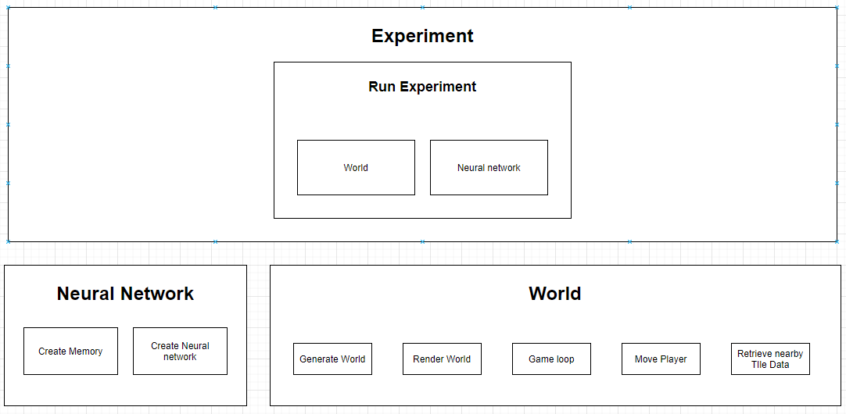

# UML

## *Class Diagram*

# 

# Features

## Feature: Generate World

Tasks:

1. Create a function that picks a random tile
2. Create a function loops through the entire grid of tiles and applies a random tile to each tile
3. Create a function that sets all tiles at the edge of the worlds bounds to walls

## Feature: Render world

Tasks:

1. Create a function that renders each tile in the world
2. Create a function that renders the player and goal
3. Create a function that renders text

## Feature: Move player

Tasks:

1. Create a function that takes a number as a direction and moves the player in the given direction

## Feature: Game loop

Tasks:

1. Create a function that runs continuously that calls the input and render functions.

## Feature: Retrieve nearby tile data

Tasks:

1. Create a function that returns an array of all 13 tiles within 2 moves of the player

## Feature: Create memory for the neural network

Tasks:

1. Create a class that handles storage states, actions and rewards
2. Create a function that takes in memory to be stored
3. Create a function that retrieves a random sample of given size from memory

## 

## Feature: Create a Neural Network

Tasks:

1. Create a class that will build a Neural network using TensorFlow
2. Create a function that will return an action chosen by the Neural network from a given state.
3. Create a function that passes given data into memory
4. Create a function that gets the Neural network to learn from it’s stored memory.

# CRC Cards

|  |  |
| --- | --- |
| Class Name : World | |
| Subclasses : | |
| Superclasses : | |
| Responsibilities | Collaborators |
| Generate a grid of tiles to a specified size |  |
| Create a player that can be moved when given input |
| Render all tiles, the player, the goal and text to the display. |

# 

|  |  |
| --- | --- |
| Class Name : Agent | |
| Subclasses : | |
| Superclasses : | |
| Responsibilities | Collaborators |
| Build a Neural network |  |
| Choose an action to perform given its current state |
| Pass states and rewards from actions taken in the world to the replay buffer | ReplayBugger |
| Learn from memory |

# 

|  |  |
| --- | --- |
| Class Name : ReplayBuffer | |
| Subclasses : | |
| Superclasses : | |
| Responsibilities | Collaborators |
| Store states actions and rewards for the agent. | Agent |
| Return a sample of memory of given size for the agent |

# 

# References

|  |  |  |
| --- | --- | --- |
| **Referenced Publication** | **Citation** | **Reference** |
| Report | Mastering the game of Go with deep neural networks and tree search | *Silver*, D. (2016). Mastering the game of Go with deep neural networks and tree search. nature |
| Website | (Violante Andre 2019) | Violante , A. (2019, March 19). Simple Reinforcement Learning: Q-learning [Online]. (URL <https://towardsdatascience.com/simple-reinforcement-learning-q-learning-fcddc4b6fe56>). (Accessed may 2020). |